**Beer Finder Website Solution Structure: -**

This application is is single page application which is designed with angular 4 using angular cli . This application some nuget packages which are present under package.json file . For example, I have used bootstrap and ngx-bootstrap. For testing purposes, I have used jasmine and karma as a test runner tool. I have used mocha reporter which shows the result of the test if they fail on the command line.

Prerequisite to application: In order to run app we need to install an extension to allow cross origin request as the web api does not support CORS. this can be installed under extension section of settings in crome browser.

Steps to run application

1. Install node js latest version from this link <https://nodejs.org/en/download/current/> .
2. Run npm version command to check the output.
3. Run “npm install angular-cli -g “ on command prompt this will install angular cli on local system globally.
4. Go to this link ( <https://github.com/yashveersingh83/BeerFinder> ) and download the application zip fill unzip it.
5. Download visual studio code and install it . Open the unzipped folder from visual studio code.
6. Inside visual studio code go to view then select Integrated terminal. After that run npm install .
7. After successful npm install . Run **ng serve** command and open crome “ http://localhost:4200/”

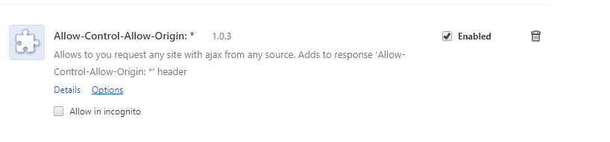

The application code is present under src folder. It basically consists of 2 main modules.

1. app.module.ts :- this is the main module which is required to run the application . This module conatain 2 components welcome and page-not-found . These components as name suggests conatins the welcome screen and if any invalid request comes or url is specified then we can make use to page-not-found component . The basic routing is defined under app-routing-module.ts file (i.e welcome and page-not-found).
2. beer-module.ts:- This modules contains all functionality required to consume the web api . This module is **lazy loaded** which means that the application support the latest feature of angular AOT compilation . This module is only loaded when we link on the beer link. The routing related to beer web api functionally reside in the beer-routing.-module.ts file . The beer module make use of beertablelist component and beer-detail component in order to show list of beer along with the search and details of the selected item.

